James Humberstone

Self-Publishing Ebooks on Amazon and iTunes

James Humberstone is a composer who has also written any number of digital publications including video courses and more recently eBooks. Focusing on two recent projects, James teaches the skills and knowledge required to create a text book and self-publish it on the Amazon Kindle store, and a children’s book on the Apple iTunes Bookstore. From using elance.com to carefully specify a job and locate a graphic artist, to filling in the US tax forms required by these ecommerce sites, as well as packaging your creative ideas for books, textbooks, or interactive projects into the right format, James will cover it all.
Self-publishing eBooks – Cheat sheet

I’m afraid I didn’t have time to do step-by-step notes for this session, but here are all of the links that I will refer to in my session.

We’re going to publish our work!
- Watch the video at http://kdp.amazon.com for inspiration.
- My first book on Amazon http://www.amazon.com/Learn-Sibelius-Hour-ebook/dp/B004GKMZ12/ref=sr_1_1?ie=UTF8&qid=1365058557&sr=8-1&keywords=learn+Sibelius+6+in+1+hour
- My first book on iTunes - https://itunes.apple.com/au/book/the-speaking-piano/id537012024?mt=11

eLance
- www.elance.com
- Speaking Piano making-of blog. http://composerhome.wordpress.com/2012/06/18/the-speaking-piano/
- A word on COPYRIGHT – you need to own your stuff if you’re going to publish it!

Making one online
- www.epubbud.com
- Online, and sent to iPad.

Making one in Word or Pages
- Hopefully Pages, export to ePub, but otherwise Word, and convert via ePubBud.
- Use the Pages template from http://support.apple.com/kb/ht4168

Validating an ePub
- http://idpf.org/epub
- http://validator.idpf.org

iBooks vs Kindle
- My blog, my thoughts… http://composerhome.wordpress.com/2012/06/07/kindle-apps-in-education/

Making interactive eBooks with iBooks author
- I will have many resources to show and share

Aggregators
- https://itunesconnect.apple.com/WebObjects/iTunesConnect.woa/wa/displayAggregators?ccTypeId=13

Selling your book in the States
- Not I am NOT a tax professional. I employed a friend to put this through for me, but you could definitely do it yourself. But my advice is NOT LEGAL ADVICE!
- You need US Tax Numbers. The forms in the folders I will provide.

Getting ISBNs
- http://www.thorpe.com.au/en-AU/default.shtml
- http://www.thorpe.com.au/en-AU/products/servident_isbn.shtml
- https://www.myidentifiers.com.au - cheaper than in US at the moment.
- Single ISBN | - $42.00
- 10 ISBNs | - $84.00
- 100 ISBNs | - $460.00
- 1,000 ISBNs | - $2,890.00
- Barcodes! Don’t buy them from Bowker - $45 each. Make your own at http://www.barcodesoft.com/online-barcode-generator.aspx - the “data to encode” is simply your ISBN, and set up as follows:
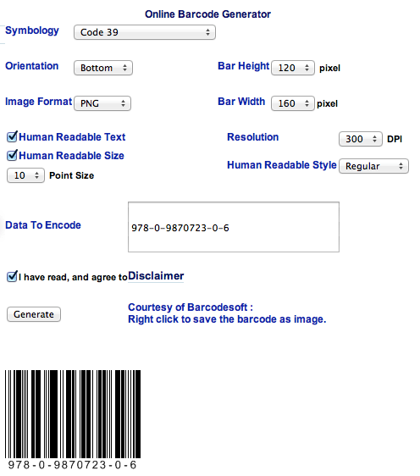

Signing up and selling with Apple
- http://www.apple.com/itunes/content-providers/book-faq.html - yes, a US tax ID is required
- https://itunesconnect.apple.com/WebObjects/iTunesConnect.woa/wa/bookSignup
- My book: https://itunes.apple.com/au/book/the-speaking-piano/id537012024?mt=11
- https://itunesconnect.apple.com/WebObjects/iTunesConnect.woa - I willl sign in and show stats (Sales and Trends)

Signing up and selling with Amazon
- https://kdp.amazon.com/self-publishing/signin
- I will log in and show data
- http://www.amazon.com/Learn-Sibelius-Hour-ebook/dp/B004GKMZ12/ref=sr_1_1?ie=UTF8&qid=1365058557&sr=8-1&keywords=learn+Sibelius+6+in+1+hour
- I will click Add new title and show how easy it is.
- When you sign up, here’s their policy on tax: https://kdp.amazon.com/self-publishing/help?topicId=A1VDYJ32T5D3U4

Print books!
- http://www.lulu.com/
- My experiences – I’ll show print versions of these eBooks

